 VINOD SIR’S GROUP TUTION
DATED: 01/28/2023
MARKS: 23 IX-MATHS-2 TIME: 1 HOUR

Q. 1 From the figure given below, find the values of: [4]
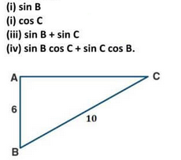
Q 2: From the figure given below, find the values of: [3]
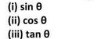
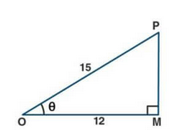

Q 3: [2]

Q 4: Find the values for the following: (Any 3) [6]
1. 2.
3. 4. 